**Gym Management System Database**

**Designs:**

**1-ERD:**

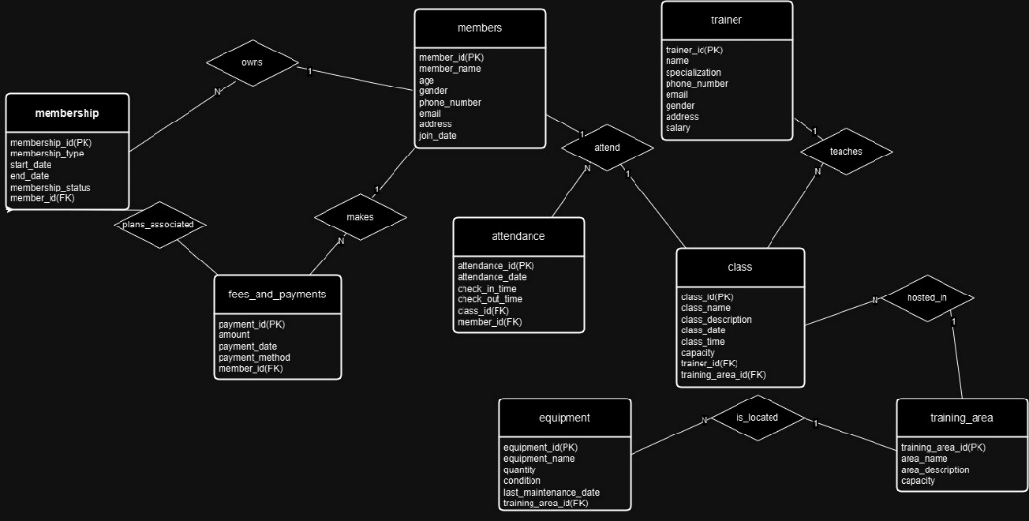

**2-EER Diagram:**

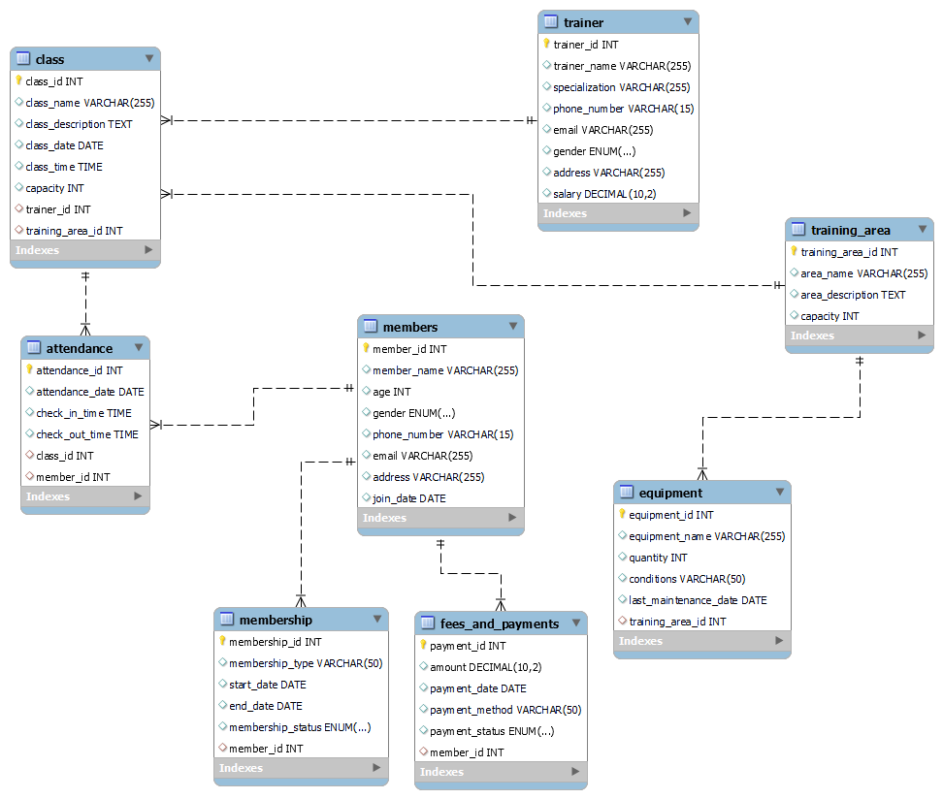

**Data:**

* **INSERT INTO members (member_id, member_name, age, gender, phone_number, email, address, join_date) VALUES**
* (1, 'John Doe', 30, 'Male', '123-456-7890', 'john.doe@example.com', '123 Main St', '2023-01-15'),
* (2, 'Jane Smith', 28, 'Female', '123-456-7891', 'jane.smith@example.com', '124 Main St', '2023-02-10'),
* (3, 'Alice Johnson', 25, 'Female', '123-456-7892', 'alice.johnson@example.com', '125 Main St', '2023-03-05'),
* (4, 'Bob Brown', 35, 'Male', '123-456-7893', 'bob.brown@example.com', '126 Main St', '2023-04-20'),
* (5, 'Charlie Davis', 22, 'Male', '123-456-7894', 'charlie.davis@example.com', '127 Main St', '2023-05-15'),
* (6, 'Diana Evans', 31, 'Female', '123-456-7895', 'diana.evans@example.com', '128 Main St', '2023-06-10'),
* (7, 'Frank Green', 29, 'Male', '123-456-7896', 'frank.green@example.com', '129 Main St', '2023-07-05'),
* (8, 'Hannah White', 27, 'Female', '123-456-7897', 'hannah.white@example.com', '130 Main St', '2023-08-01'),
* (9, 'Ian Black', 33, 'Male', '123-456-7898', 'ian.black@example.com', '131 Main St', '2023-09-01'),
* (10, 'Julie Miller', 24, 'Female', '123-456-7899', 'julie.miller@example.com', '132 Main St', '2023-10-01'),
* (11, 'Kevin Scott', 26, 'Male', '123-456-7900', 'kevin.scott@example.com', '133 Main St', '2023-11-01'),
* (12, 'Laura Adams', 32, 'Female', '123-456-7901', 'laura.adams@example.com', '134 Main St', '2023-12-01'),
* (13, 'Michael Wilson', 34, 'Male', '123-456-7902', 'michael.wilson@example.com', '135 Main St', '2024-01-01'),
* (14, 'Nancy Clark', 21, 'Female', '123-456-7903', 'nancy.clark@example.com', '136 Main St', '2024-02-01'),
* (15, 'Oscar Turner', 28, 'Male', '123-456-7904', 'oscar.turner@example.com', '137 Main St', '2024-03-01'),
* (16, 'Paula Lewis', 29, 'Female', '123-456-7905', 'paula.lewis@example.com', '138 Main St', '2024-04-01'),
* (17, 'Quentin Harris', 30, 'Male', '123-456-7906', 'quentin.harris@example.com', '139 Main St', '2024-05-01'),
* (18, 'Rachel King', 27, 'Female', '123-456-7907', 'rachel.king@example.com', '140 Main St', '2024-06-01'),
* (19, 'Steve Martinez', 31, 'Male', '123-456-7908', 'steve.martinez@example.com', '141 Main St', '2024-07-01'),
* (20, 'Tina Robinson', 33, 'Female', '123-456-7909', 'tina.robinson@example.com', '142 Main St', '2024-08-01'),
* (11, 'Kevin Scott', 26, 'Male', '123-456-7900', 'kevin.scott@example.com', '133 Main St', '2023-11-01'),
* (21, 'Tommy Lee', 30, 'Male', '123-456-7910', 'tommy.lee@example.com', '143 Main St', '2024-04-02'),
* (31, 'Emma Watson', 28, 'Female', '123-456-7920', 'emma.watson@example.com', '144 Main St', '2024-04-03'),
* (41, 'Liam Neeson', 35, 'Male', '123-456-7930', 'liam.neeson@example.com', '145 Main St', '2024-04-04'),
* (52, 'Chloe Grace', 25, 'Female', '123-456-7940', 'chloe.grace@example.com', '146 Main St', '2024-04-05'),
* (61, 'Sophia Bush', 29, 'Female', '123-456-7950', 'sophia.bush@example.com', '147 Main St', '2024-04-06'),
* (71, 'Chris Evans', 31, 'Male', '123-456-7960', 'chris.evans@example.com', '148 Main St', '2024-04-07'),
* (82, 'Natalie Portman', 28, 'Female', '123-456-7970', 'natalie.portman@example.com', '149 Main St', '2024-04-08'),
* (92, 'David Beckham', 34, 'Male', '123-456-7980', 'david.beckham@example.com', '150 Main St', '2024-04-09'),
* (102, 'Scarlett Johansson', 27, 'Female', '123-456-7990', 'scarlett.johansson@example.com', '151 Main St', '2024-04-10'),
* (116, 'Rachel Green', 28, 'Female', '123-456-8000', 'rachel.green@example.com', '152 Main St', '2024-05-11'),
* (126, 'Monica Geller', 30, 'Female', '123-456-8010', 'monica.geller@example.com', '153 Main St', '2024-05-12'),
* (136, 'Phoebe Buffay', 33, 'Female', '123-456-8020', 'phoebe.buffay@example.com', '154 Main St', '2024-05-13'),
* (144, 'Ross Geller', 32, 'Male', '123-456-8030', 'ross.geller@example.com', '155 Main St', '2024-05-14'),
* (15, 'Oscar Turner', 28, 'Male', '123-456-7904', 'oscar.turner@example.com', '137 Main St', '2024-03-01'),
* (251, 'Member 251', 25, 'Male', '123-456-8050', 'member251@example.com', '156 Main St', '2024-05-16'),
* (351, 'Member 351', 30, 'Female', '123-456-8060', 'member351@example.com', '157 Main St', '2024-05-17'),
* (4415, 'Member 4415', 35, 'Male', '123-456-8070', 'member4415@example.com', '158 Main St', '2024-05-18'),
* (51452, 'Member 51452', 40, 'Male', '123-456-8080', 'member51452@example.com', '159 Main St', '2024-05-19'),
* (6515, 'Member 6515', 25, 'Female', '123-456-8090', 'member6515@example.com', '160 Main St', '2024-05-20'),
* (714, 'Member 714', 32, 'Male', '123-456-8100', 'member714@example.com', '161 Main St', '2024-05-21'),
* (2211010, 'Member 2211010', 29, 'Male', '123-456-8110', 'member2211010@example.com', '162 Main St', '2024-04-01'),
* (2211011, 'Member 2211011', 30, 'Female', '123-456-8120', 'member2211011@example.com', '163 Main St', '2024-04-02'),
* (2211012, 'Member 2211012', 28, 'Male', '123-456-8130', 'member2211012@example.com', '164 Main St', '2024-04-03'),
* (2211013, 'Member 2211013', 32, 'Female', '123-456-8140', 'member2211013@example.com', '165 Main St', '2024-04-04'),
* (2211014, 'Member 2211014', 35, 'Male', '123-456-8150', 'member2211014@example.com', '166 Main St', '2024-04-05'),
* (2211015, 'Member 2211015', 31, 'Female', '123-456-8160', 'member2211015@example.com', '167 Main St', '2024-04-06'),
* (2211016, 'Member 2211016', 33, 'Male', '123-456-8170', 'member2211016@example.com', '168 Main St', '2024-04-07'),
* (2211017, 'Member 2211017', 30, 'Female', '123-456-8180', 'member2211017@example.com', '169 Main St', '2024-04-08'),
* (2211018, 'Member 2211018', 29, 'Male', '123-456-8190', 'member2211018@example.com', '170 Main St', '2024-04-09'),
* (2211019, 'Member 2211019', 28, 'Female', '123-456-8200', 'member2211019@example.com', '171 Main St', '2024-04-10'),
* (2211020, 'Member 2211020', 27, 'Male', '123-456-8210', 'member2211020@example.com', '172 Main St', '2024-04-11'),
* (2211021, 'Member 2211021', 32, 'Female', '123-456-8220', 'member2211021@example.com', '173 Main St', '2024-04-12'),
* (2211022, 'Member 2211022', 33, 'Male', '123-456-8230', 'member2211022@example.com', '174 Main St', '2024-04-13'),
* (2211023, 'Member 2211023', 29, 'Female', '123-456-8240', 'member2211023@example.com', '175 Main St', '2024-04-14'),
* (2211024, 'Member 2211024', 31, 'Male', '123-456-8250', 'member2211024@example.com', '176 Main St', '2024-04-15'),
* (2211025, 'Member 2211025', 34, 'Female', '123-456-8260', 'member2211025@example.com', '177 Main St', '2024-04-16'),
* (2211026, 'Member 2211026', 32, 'Male', '123-456-8270', 'member2211026@example.com', '178 Main St', '2024-04-17'),
* (2211027, 'Member 2211027', 33, 'Female', '123-456-8280', 'member2211027@example.com', '179 Main St', '2024-04-18'),
* (2211028, 'Member 2211028', 29, 'Male', '123-456-8290', 'member2211028@example.com', '180 Main St', '2024-04-19'),
* (2211029, 'Member 2211029', 27, 'Female', '123-456-8300', 'member2211029@example.com', '181 Main St', '2024-04-20'),
* (2211030, 'Member 2211030', 31, 'Male', '123-456-8310', 'member2211030@example.com', '182 Main St', '2024-04-21'),
* (2211031, 'Member 2211031', 33, 'Female', '123-456-8320', 'member2211031@example.com', '183 Main St', '2024-04-22'),
* (2211032, 'Member 2211032', 30, 'Male', '123-456-8330', 'member2211032@example.com', '184 Main St', '2024-04-23'),
* (2211033, 'Member 2211033', 34, 'Female', '123-456-8340', 'member2211033@example.com', '185 Main St', '2024-04-24'),
* (2211034, 'Member 2211034', 32, 'Male', '123-456-8350', 'member2211034@example.com', '186 Main St', '2024-04-25'),
* (2211035, 'Member 2211035', 29, 'Female', '123-456-8360', 'member2211035@example.com', '187 Main St', '2024-04-26'),
* (2211036, 'Member 2211036', 31, 'Male', '123-456-8370', 'member2211036@example.com', '188 Main St', '2024-04-27'),
* (2211037, 'Member 2211037', 33, 'Female', '123-456-8380', 'member2211037@example.com', '189 Main St', '2024-04-28'),
* (2211038, 'Member 2211038', 34, 'Male', '123-456-8390', 'member2211038@example.com', '190 Main St', '2024-04-29');
* INSERT INTO trainer (trainer_id, trainer_name, specialization, phone_number, email, gender, address, salary) VALUES
  + (1, 'Trainer One', 'Yoga', '123-456-7910', 'trainer.one@example.com', 'Male', '143 Main St', 50000),
  + (2, 'Trainer Two', 'Pilates', '123-456-7911', 'trainer.two@example.com', 'Female', '144 Main St', 52000),
  + (3, 'Trainer Three', 'Weightlifting', '123-456-7912', 'trainer.three@example.com', 'Male', '145 Main St', 48000),
  + (4, 'Trainer Four', 'Cardio', '123-456-7913', 'trainer.four@example.com', 'Female', '146 Main St', 51000),
  + (5, 'Trainer Five', 'CrossFit', '123-456-7914', 'trainer.five@example.com', 'Male', '147 Main St', 49000),
  + (6, 'Trainer Six', 'Aerobics', '123-456-7915', 'trainer.six@example.com', 'Female', '148 Main St', 50000),
  + (7, 'Trainer Seven', 'Martial Arts', '123-456-7916', 'trainer.seven@example.com', 'Male', '149 Main St', 53000),
  + (8, 'Trainer Eight', 'Zumba', '123-456-7917', 'trainer.eight@example.com', 'Female', '150 Main St', 52000),
  + (9, 'Trainer Nine', 'Swimming', '123-456-7918', 'trainer.nine@example.com', 'Male', '151 Main St', 51000),
  + (10, 'Trainer Ten', 'Boxing', '123-456-7919', 'trainer.ten@example.com', 'Female', '152 Main St', 49000),
  + (11, 'Trainer Eleven', 'Yoga', '123-456-7920', 'trainer.eleven@example.com', 'Male', '153 Main St', 50000),
  + (12, 'Trainer Twelve', 'Pilates', '123-456-7921', 'trainer.twelve@example.com', 'Female', '154 Main St', 52000),
  + (13, 'Trainer Thirteen', 'Weightlifting', '123-456-7922', 'trainer.thirteen@example.com', 'Male', '155 Main St', 48000),
  + (14, 'Trainer Fourteen', 'Cardio', '123-456-7923', 'trainer.fourteen@example.com', 'Female', '156 Main St', 51000),
  + (15, 'Trainer Fifteen', 'CrossFit', '123-456-7924', 'trainer.fifteen@example.com', 'Male', '157 Main St', 49000),
  + (16, 'Trainer Sixteen', 'Aerobics', '123-456-7925', 'trainer.sixteen@example.com', 'Female', '158 Main St', 50000),
  + (17, 'Trainer Seventeen', 'Martial Arts', '123-456-7926', 'trainer.seventeen@example.com', 'Male', '159 Main St', 53000),
  + (18, 'Trainer Eighteen', 'Zumba', '123-456-7927', 'trainer.eighteen@example.com', 'Female', '160 Main St', 52000),
  + (19, 'Trainer Nineteen', 'Swimming', '123-456-7928', 'trainer.nineteen@example.com', 'Male', '161 Main St', 51000),
  + (20, 'Trainer Twenty', 'Boxing', '123-456-7929', 'trainer.twenty@example.com', 'Female', '162 Main St', 49000);
* **INSERT INTO membership (membership_id, membership_type, start_date, end_date, membership_status, member_id) VALUES**
  + (1, 'Monthly', '2023-01-01', '2023-01-31', 'Expired', 1),
  + (2, 'Monthly', '2023-02-01', '2023-02-28', 'Expired', 2),
  + (3, 'Monthly', '2023-03-01', '2023-03-31', 'Expired', 3),
  + (4, 'Monthly', '2023-04-01', '2023-04-30', 'Expired', 4),
  + (5, 'Monthly', '2023-05-01', '2023-05-31', 'Expired', 5),
  + (6, 'Monthly', '2023-06-01', '2023-06-30', 'Inactive', 6),
  + (7, 'Monthly', '2023-07-01', '2023-07-31', 'Inactive', 7),
  + (8, 'Monthly', '2023-08-01', '2023-08-31', 'Inactive', 8),
  + (9, 'Monthly', '2023-09-01', '2023-09-30', 'Inactive', 9),
  + (10, 'Monthly', '2023-10-01', '2023-10-31', 'Inactive', 10),
  + (11, 'Monthly', '2023-11-01', '2023-11-30', 'Active', 11),
  + (12, 'Monthly', '2023-12-01', '2023-12-31', 'Active', 12),
  + (13, 'Monthly', '2024-01-01', '2024-01-31', 'Active', 13),
  + (14, 'Monthly', '2024-02-01', '2024-02-28', 'Active', 14),
  + (15, 'Monthly', '2024-03-01', '2024-03-31', 'Active', 15),
  + (16, 'Monthly', '2024-04-01', '2024-04-30', 'Active', 16),
  + (17, 'Monthly', '2024-05-01', '2024-05-31', 'Active', 17),
  + (18, 'Monthly', '2024-06-01', '2024-06-30', 'Active', 18),
  + (19, 'Monthly', '2024-07-01', '2024-07-31', 'Active', 19),
  + (20, 'Monthly', '2024-08-01', '2024-08-31', 'Active', 20);
* **INSERT INTO fees_and_payments (payment_id, amount, payment_date, payment_method, payment_status, member_id) VALUES**
  + (1, 50.00, '2023-01-01', 'Credit Card', 'Paid', 1),
  + (2, 55.00, '2023-02-01', 'Credit Card', 'Unpaid', 2),
  + (3, 60.00, '2023-03-01', 'Credit Card', 'Paid', 3),
  + (4, 65.00, '2023-04-01', 'Credit Card', 'Unpaid', 4),
  + (5, 70.00, '2023-05-01', 'Credit Card', 'Paid', 5),
  + (6, 75.00, '2023-06-01', 'Credit Card', 'Unpaid', 6),
  + (7, 80.00, '2023-07-01', 'Credit Card', 'Paid', 7),
  + (8, 85.00, '2023-08-01', 'Credit Card', 'Unpaid', 8),
  + (9, 90.00, '2023-09-01', 'Credit Card', 'Paid', 9),
  + (10, 95.00, '2023-10-01', 'Credit Card', 'Unpaid', 10),
  + (11, 100.00, '2023-11-01', 'Credit Card', 'Paid', 11),
  + (12, 105.00, '2023-12-01', 'Credit Card', 'Unpaid', 12),
  + (13, 110.00, '2024-01-01', 'Credit Card', 'Paid', 13),
  + (14, 115.00, '2024-02-01', 'Credit Card', 'Unpaid', 14),
  + (15, 120.00, '2024-03-01', 'Credit Card', 'Paid', 15),
  + (16, 125.00, '2024-04-01', 'Credit Card', 'Unpaid', 16),
  + (17, 130.00, '2024-05-01', 'Credit Card', 'Paid', 17),
  + (18, 135.00, '2024-06-01', 'Credit Card', 'Unpaid', 18),
  + (19, 140.00, '2024-07-01', 'Credit Card', 'Paid', 19),
  + (20, 145.00, '2024-08-01', 'Credit Card', 'Unpaid', 20);
* **INSERT INTO training_area (training_area_id, area_name, area_description, capacity) VALUES**
  + (1, 'Main Gym Floor', 'General workout area with machines and weights', 50),
  + (2, 'Cardio Room', 'Room with cardio equipment', 30),
  + (3, 'Free Weights Room', 'Room with free weights and benches', 20),
  + (4, 'Group Class Studio', 'Studio for group fitness classes', 25),
  + (5, 'Cycling Studio', 'Studio with stationary bikes', 20),
  + (6, 'Yoga Studio', 'Peaceful studio for yoga classes', 30),
  + (7, 'Pilates Studio', 'Studio for pilates classes', 20),
  + (8, 'Boxing Ring', 'Area with boxing equipment', 15),
  + (9, 'Swimming Pool', 'Indoor swimming pool', 25),
  + (10, 'Outdoor Training Area', 'Open-air area for outdoor workouts', 35);
* **INSERT INTO equipment (equipment_id, equipment_name, quantity, conditions, last_maintenance_date, training_area_id) VALUES**
  + (1, 'Treadmill', 10, 'Good', '2023-01-01', 1),
  + (2, 'Stationary Bike', 5, 'Fair', '2023-02-01', 2),
  + (3, 'Dumbbells', 20, 'Excellent', '2023-03-01', 3),
  + (4, 'Bench Press', 5, 'Good', '2023-04-01', 4),
  + (5, 'Rowing Machine', 3, 'Good', '2023-05-01', 5),
  + (6, 'Elliptical', 6, 'Fair', '2023-06-01', 6),
  + (7, 'Squat Rack', 4, 'Excellent', '2023-07-01', 7),
  + (8, 'Leg Press', 3, 'Good', '2023-08-01', 8),
  + (9, 'Kettlebells', 15, 'Fair', '2023-09-01', 9),
  + (10, 'Pull-Up Bar', 2, 'Good', '2023-10-01', 10),
  + (11, 'Yoga Mats', 30, 'Excellent', '2023-11-01', 1),
  + (12, 'Resistance Bands', 25, 'Good', '2023-12-01', 2),
  + (13, 'Medicine Balls', 10, 'Fair', '2024-01-01', 3),
  + (14, 'Battle Ropes', 5, 'Good', '2024-02-01', 4),
  + (15, 'Plyo Boxes', 7, 'Excellent', '2024-03-01', 5),
  + (16, 'Smith Machine', 2, 'Good', '2024-04-01', 6),
  + (17, 'Jump Ropes', 20, 'Fair', '2024-05-01', 7),
  + (18, 'Punching Bags', 6, 'Good', '2024-06-01', 8),
  + (19, 'Stepper Machine', 4, 'Excellent', '2024-07-01', 9),
  + (20, 'Foam Rollers', 12, 'Good', '2024-08-01', 10);
* **INSERT INTO class (class_id, class_name, class_description, class_date, class_time, capacity, trainer_id, training_area_id) VALUES**
  + (1, 'Yoga Basics', 'Introductory yoga class', '2024-01-01', '09:00:00', 20, 1, 1),
  + (2, 'Advanced Pilates', 'Advanced pilates techniques', '2024-01-02', '10:00:00', 15, 2, 2),
  + (3, 'Weightlifting 101', 'Beginner weightlifting class', '2024-01-03', '11:00:00', 25, 3, 3),
  + (4, 'Cardio Blast', 'High-intensity cardio workout', '2024-01-04', '12:00:00', 30, 4, 4),
  + (5, 'CrossFit Challenge', 'Intense CrossFit session', '2024-01-05', '13:00:00', 20, 5, 5),
  + (6, 'Aerobics Fun', 'Energetic aerobics class', '2024-01-06', '14:00:00', 25, 6, 6),
  + (7, 'Martial Arts Intro', 'Basics of martial arts', '2024-01-07', '15:00:00', 20, 7, 7),
  + (8, 'Zumba Party', 'Dance-based fitness class', '2024-01-08', '16:00:00', 30, 8, 8),
  + (9, 'Swimming Techniques', 'Improve your swimming skills', '2024-01-09', '17:00:00', 15, 9, 9),
  + (10, 'Boxing Basics', 'Intro to boxing', '2024-01-10', '18:00:00', 20, 10, 10),
  + (11, 'Yoga Flow', 'Intermediate yoga class', '2024-01-11', '09:00:00', 20, 11, 1),
  + (12, 'Pilates Power', 'Intense pilates workout', '2024-01-12', '10:00:00', 15, 12, 2),
  + (13, 'Weightlifting Pro', 'Advanced weightlifting techniques', '2024-01-13', '11:00:00', 25, 13, 3),
  + (14, 'Cardio Mania', 'Extreme cardio workout', '2024-01-14', '12:00:00', 30, 14, 4),
  + (15, 'CrossFit Extreme', 'Advanced CrossFit session', '2024-01-15', '13:00:00', 20, 15, 5),
  + (16, 'Aerobics Fever', 'High-energy aerobics class', '2024-01-16', '14:00:00', 25, 16, 6),
  + (17, 'Martial Arts Advanced', 'Advanced martial arts techniques', '2024-01-17', '15:00:00', 20, 17, 7),
  + (18, 'Zumba Extreme', 'High-energy dance workout', '2024-01-18', '16:00:00', 30, 18, 8),
  + (19, 'Swimming Pro', 'Advanced swimming techniques', '2024-01-19', '17:00:00', 15, 19, 9),
  + (20, 'Boxing Pro', 'Advanced boxing techniques', '2024-01-20', '18:00:00', 20, 20, 10);
* **INSERT INTO attendance (attendance_id, attendance_date, check_in_time, check_out_time, class_id, member_id) VALUES**
* (1, '2024-01-01', '09:00:00', '10:00:00', 1, 1),
* (2, '2024-01-02', '10:00:00', '11:00:00', 2, 2),
* (3, '2024-01-03', '11:00:00', '12:00:00', 3, 3),
* (4, '2024-01-04', '12:00:00', '13:00:00', 4, 4),
* (5, '2024-01-05', '13:00:00', '14:00:00', 5, 5),
* (6, '2024-01-06', '14:00:00', '15:00:00', 6, 6),
* (7, '2024-01-07', '15:00:00', '16:00:00', 7, 7),
* (8, '2024-01-08', '16:00:00', '17:00:00', 8, 8),
* (9, '2024-01-09', '17:00:00', '18:00:00', 9, 9),
* (10, '2024-01-10', '18:00:00', '19:00:00', 10, 10),
* (11, '2024-01-11', '09:00:00', '10:00:00', 11, 11),
* (12, '2024-01-12', '10:00:00', '11:00:00', 12, 12),
* (13, '2024-01-13', '11:00:00', '12:00:00', 13, 13),
* (14, '2024-01-14', '12:00:00', '13:00:00', 14, 14),
* (15, '2024-01-15', '13:00:00', '14:00:00', 15, 15),
* (16, '2024-01-16', '14:00:00', '15:00:00', 16, 16),
* (17, '2024-01-17', '15:00:00', '16:00:00', 17, 17),
* (18, '2024-01-18', '16:00:00', '17:00:00', 18, 18),
* (19, '2024-01-19', '17:00:00', '18:00:00', 19, 19),
* (20, '2024-01-20', '18:00:00', '19:00:00', 20, 20),
* (21, '2024-01-01', '09:00:00', '10:00:00', 1, 1),
* (22, '2024-01-02', '10:00:00', '11:00:00', 2, 1),
* (23, '2024-01-03', '11:00:00', '12:00:00', 3, 1),
* (24, '2024-01-04', '12:00:00', '13:00:00', 4, 3),
* (25, '2024-01-05', '13:00:00', '14:00:00', 5, 3),
* (26, '2024-01-06', '14:00:00', '15:00:00', 6, 3),
* (27, '2024-01-07', '15:00:00', '16:00:00', 7, 4),
* (28, '2024-01-08', '16:00:00', '17:00:00', 8, 6),
* (29, '2024-01-09', '17:00:00', '18:00:00', 9, 6),
* (30, '2024-01-10', '18:00:00', '19:00:00', 10, 16),
* (31, '2024-01-11', '09:00:00', '10:00:00', 11, 16),
* (32, '2024-01-12', '10:00:00', '11:00:00', 12, 16),
* (33, '2024-01-13', '11:00:00', '12:00:00', 13, 13),
* (34, '2024-01-14', '12:00:00', '13:00:00', 14, 15),
* (35, '2024-01-15', '13:00:00', '14:00:00', 15, 15),
* (36, '2024-01-16', '14:00:00', '15:00:00', 16, 13),
* (37, '2024-01-17', '15:00:00', '16:00:00', 17, 12),
* (38, '2024-01-18', '16:00:00', '17:00:00', 18, 9),
* (39, '2024-01-19', '17:00:00', '18:00:00', 19, 1),
* (40, '2024-01-20', '18:00:00', '19:00:00', 20, 1),
* (100, '2024-05-01', '09:00:00', '10:00:00', 1, 11),
* (200, '2024-05-02', '10:00:00', '11:00:00', 2, 21),
* (300, '2024-05-03', '11:00:00', '12:00:00', 3, 31),
* (400, '2024-05-04', '12:00:00', '13:00:00', 4, 41),
* (500, '2024-05-05', '13:00:00', '14:00:00', 5, 52),
* (600, '2024-05-06', '14:00:00', '15:00:00', 6, 61),
* (700, '2024-05-07', '15:00:00', '16:00:00', 7, 71),
* (800, '2024-05-08', '16:00:00', '17:00:00', 8, 82),
* (900, '2024-05-09', '17:00:00', '18:00:00', 9, 92),
* (110, '2024-05-11', '09:00:00', '10:00:00', 11, 116),
* (120, '2024-05-12', '10:00:00', '11:00:00', 12, 126),
* (130, '2024-05-13', '11:00:00', '12:00:00', 13, 136),
* (140, '2024-05-14', '12:00:00', '13:00:00', 14, 144),
* (1000, '2024-05-15', '09:00:00', '10:00:00', 1, 15),
* (2000, '2024-05-16', '10:00:00', '11:00:00', 2, 251),
* (3000, '2024-05-17', '11:00:00', '12:00:00', 3, 351),
* (4000, '2024-05-18', '12:00:00', '13:00:00', 4, 4415),
* (5000, '2024-05-19', '13:00:00', '14:00:00', 5, 51452),
* (6000, '2024-05-20', '14:00:00', '15:00:00', 6, 6515),
* (7000, '2024-05-21', '15:00:00', '16:00:00', 7, 714),
* (8000,'2024-04-01', '09:00:00', '10:00:00', 1, 2211010),
* (9000,'2024-04-02', '09:30:00', '10:30:00', 2, 2211011),
* (1111,'2024-04-03', '10:00:00', '11:00:00', 3, 2211012),
* (1112,'2024-04-04', '10:30:00', '11:30:00', 4, 2211013),
* (1113,'2024-04-05', '11:00:00', '12:00:00', 5, 2211014),
* (1114,'2024-04-06', '11:30:00', '12:30:00', 6, 2211015),
* (1115,'2024-04-07', '12:00:00', '13:00:00', 7, 2211016),
* (1116,'2024-04-08', '12:30:00', '13:30:00', 8, 2211017),
* (1117,'2024-04-09', '13:00:00', '14:00:00', 9, 2211018),
* (1118,'2024-04-10', '13:30:00', '14:30:00', 10, 2211019),
* (1119,'2024-04-11', '14:00:00', '15:00:00', 1, 2211020),
* (1120,'2024-04-12', '14:30:00', '15:30:00', 2, 2211021),
* (1121,'2024-04-13', '15:00:00', '16:00:00', 3, 2211022),
* (1122,'2024-04-14', '15:30:00', '16:30:00', 4, 2211023),
* (1123,'2024-04-15', '16:00:00', '17:00:00', 5, 2211024),
* (1124,'2024-04-16', '16:30:00', '17:30:00', 6, 2211025),
* (1125,'2024-04-17', '17:00:00', '18:00:00', 7, 2211026),
* (1126,'2024-04-18', '17:30:00', '18:30:00', 8, 2211027),
* (1127,'2024-04-19', '18:00:00', '19:00:00', 9, 2211028),
* (1128,'2024-04-20', '18:30:00', '19:30:00', 10, 2211029),
* (1129,'2024-04-21', '19:00:00', '20:00:00', 1, 2211030),
* (1130,'2024-04-22', '19:30:00', '20:30:00', 2, 2211031),
* (1131,'2024-04-23', '20:00:00', '21:00:00', 3, 2211032),
* (1132,'2024-04-24', '20:30:00', '21:30:00', 4, 2211033),
* (1134,'2024-04-25', '21:00:00', '22:00:00', 5, 2211034),
* (1135,'2024-04-26', '21:30:00', '22:30:00', 6, 2211035),
* (1136,'2024-04-27', '22:00:00', '23:00:00', 7, 2211036),
* (1137,'2024-04-28', '22:30:00', '23:30:00', 8, 2211037),
* (1138,'2024-04-29', '23:00:00', '00:00:00', 9, 2211038);

**Queries:**

* **Query to Retrieve Member’s Class Schedule**
  + SELECT
  + m.member_name,
  + c.class_name,
  + c.class_date,
  + c.class_time,
  + ta.area_name
  + FROM
  + members m
  + JOIN
  + attendance a ON m.member_id = a.member_id
  + JOIN
  + class c ON a.class_id = c.class_id
  + JOIN
  + training_area ta ON c.training_area_id = ta.training_area_id
  + WHERE
  + m.member_id = 1;

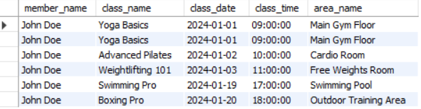

* **Query to Retrieve Classes Taught by a Trainer**
  + SELECT
  + t.trainer_name,
  + c.class_name,
  + c.class_date,
  + c.class_time,
  + ta.area_name
  + FROM
  + trainer t
  + JOIN
  + class c ON t.trainer_id = c.trainer_id
  + JOIN
  + training_area ta ON c.training_area_id = ta.training_area_id
  + WHERE
  + t.trainer_id = 5;



* **Query to Retrieve Equipment Due for Maintenance**
  + SELECT
  + e.equipment_name,
  + e.quantity,
  + e.conditions,
  + e.last_maintenance_date,
  + ta.area_name
  + FROM
  + equipment e
  + JOIN
  + training_area ta ON e.training_area_id = ta.training_area_id
  + WHERE
  + e.last_maintenance_date < DATE_SUB(CURDATE(), INTERVAL 6 MONTH);

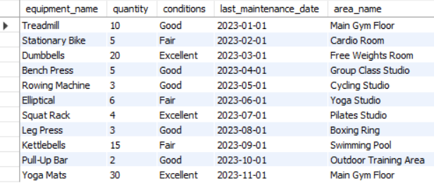

* **Query to Retrieve Members with Expired Memberships**
  + SELECT
  + m.member_name,
  + me.membership_type,
  + me.start_date,
  + me.end_date
  + FROM
  + members m
  + JOIN
  + membership me ON m.member_id = me.member_id
  + WHERE
  + me.membership_status = 'Expired';

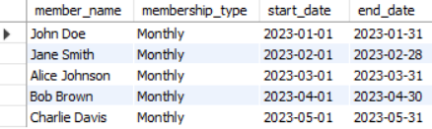

* **Query to retrieve Classes with the Highest Attendance**
  + SELECT
  + c.class_name,
  + COUNT(a.attendance_id) AS attendance_count
  + FROM
  + class c
  + JOIN
  + attendance a ON c.class_id = a.class_id
  + GROUP BY
  + c.class_id
  + ORDER BY
  + attendance_count DESC
  + LIMIT 1;



* **Query to Retrieve Trainers who teach the most classes**
  + SELECT
  + t.trainer_name ,
  + COUNT(c.class_id) AS class_count
  + FROM
  + trainer t
  + JOIN
  + class c ON t.trainer_id = c.trainer_id
  + GROUP BY
  + t.trainer_id
  + ORDER BY
  + class_count DESC
  + LIMIT 1;



* **Query to Calculate Total Revenue from Memberships this Month**
  + SELECT
  + SUM(fp.amount) AS total_revenue
  + FROM
  + fees_and_payments fp
  + WHERE
  + MONTH(fp.payment_date) = MONTH(CURDATE())
  + AND YEAR(fp.payment_date) = YEAR(CURDATE())
  + AND fp.payment_status = 'Paid';



* **Query to Retrieve Members with Unpaid Payments**
  + SELECT
  + m.member_name,
  + fp.amount,
  + fp.payment_date
  + FROM
  + members m
  + JOIN
  + fees_and_payments fp ON m.member_id = fp.member_id
  + WHERE
  + fp.payment_status = 'Unpaid';

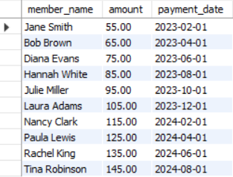

* **Query to Calculate the Percentage of Members Who Attended Classes Last Month**
  + SELECT
  + (SELECT COUNT(DISTINCT a.member_id)
  + FROM attendance a
  + WHERE
  + MONTH(a.attendance_date) = MONTH(CURDATE() - INTERVAL 1 MONTH)
  + AND YEAR(a.attendance_date) = YEAR(CURDATE() - INTERVAL 1 MONTH))
  + /
  + (SELECT COUNT(*) FROM members) * 100.0 AS attendance_percentage;

